The Monthly Book Report

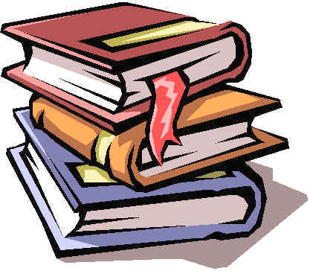

Objective: Students will be able to write a clear and concise book report, which is divided into various sections based on the elements of a novel: the protagonist, antagonist, conflict, setting, plot, climax, denouement, and theme.

Procedures: At the beginning of every month students will select a book they will read and write a book report. Students will work on the report during class time. A special attention will be focused on time management and writing skills. At the end of every report, students will grow as readers, writers, and critical thinkers.

Book Selection: The teacher will pre-select possible books for students to read based on their reading level and interest. Most books will be Newbery award winners and/or other first-rate books.

Elements of a Novel

Protagonist: The main character of the novel/story.

Antagonist: The opposing force in the novel/story. It might be an institution and/or a character or group of characters.

Conflict: An issue between two characters or forces. Usually is the central issue of the story.

Setting: Time, place, and conditions of the novel/story.

Plot: Describes the events that happen in the story or make up the main part of the story. It might be in sequence, cause and effect, etc.

Climax: Is the highest point of the story. Either the main part of the story or when the story takes a drastic turn.

Denouement: The End of the story/novel.

Theme: The main idea of the story. What is the author’s message?

