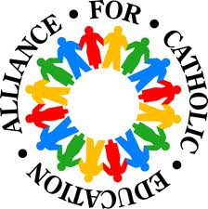
5th Grade Classroom
Current Events Outline

Objective: Students will be able to demonstrate comprehension and application skills by presenting a current event that highlights something happening around the world.

Student Name:_____________________________ Date:_______

Please circle the following type of news you will be reporting:

Global News International News State News Local News

Procedures:
- Think about a topic you are interested in (sports, animals, science, etc.)
- Google search current events ( _____insert your topic here____)
- Once you decide on an article (news piece) read it and complete the information below while you read.
- Once outline is completed: Write a Summary using the information below. (6-8 Pages) and include a picture or caption from the article.
List the resources that you use to find your information here: | Who: Who is the article about?
What: What are the main points to the article? | When: When did the date of the researched event take place?
Where: Where did the current event take place? | Why: What makes this event so interesting that people would care that it took place?

