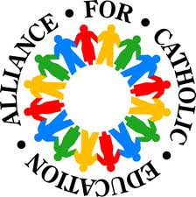
5th Grade Classroom
Current Events

Objective: Students will be able to demonstrate comprehension and application skills by presenting a current event that highlights something happening around the world.

DOB Standards | Objectives/Habits of Minds
DOB, S.S: Students will explore various news outlets. | Evidence: Students cite where they gathered the information.
DOB, S.S: Students use meaningful content to apply in real life situations. | Precision and Accuracy: Students present valuable information in a concise manner.

Guidelines: Students will present a current event every Tuesday and Thursday. Students are expected to write a brief summary of the event, highlight the importance and/or make a connection to a historical event, and cite/reference where they gathered the information. Paper must be submitted for full credit.

Fall Semester Presentations:
Aug 25 |  | Nov 3
27 |  | 5
Sep 1 |  | 10
3 |  | 12
8 |  | 17
10 |  | 19
22 |  | Dec 1
23 |  | 3
29 |  | 8
Oct 1 |  | 10
6 |  | 15
8
13
15
20
22
28
29

Acceptable References: Local/State/National Newspapers, TV News, Online News Media

Recommended Cites: CNN Student News

Note Taking: Students are expected to take-notes for every Current Event presented by their classmates. Notes will be collected for Participation points.

